The Bigollφ Theorem
Three Doors in the Cantor Gate
How a Fibonacci fractal predicts structure from atoms to the cosmos

Thomas A. Husmann — iBuilt LTD, Lilliwaup, Washington, USA
March 2026

Abstract
The companion Bigollφ Method paper showed that a single Pythagorean formula predicts atomic radius ratios for 97 elements with zero free parameters. In the process, three quantized values (1.146, 1.311, 1.409) appeared as horizontal bands in the scatter plot—three discrete confinement modes atoms choose from like travelers choosing doors. This paper tests whether the same three modes recur across unrelated scales.
We examine consecutive ratios in homonuclear diatomic bond lengths, diamond-structure lattice constants, TRAPPIST-1 exoplanet orbits, and solar-system orbital spacings. Nine of twenty-two ratios land within 2% of one of the three modes (mean error 0.62%). A Monte Carlo test against 100,000 random triples yields p = 5 × 10⁻⁵. The relativistic correction ρ₆ = φ^{1/6} = 1.0835 matches the local-to-CMB Hubble-constant ratio (73.0/67.4) to 0.039% (cross-bracket p < 10⁻⁵). Kepler statistics independently confirm that FGK-host systems peak at the crossover mode (a-ratio 1.310) while M-dwarf systems favor the baseline mode (1.409). Fisher’s combined p-value is 1.81 × 10⁻¹³.
The Bigollφ Theorem: the critical Fibonacci Hamiltonian generates three quantized confinement modes that organize matter from molecules to the universe.

The Scatter Plot That Started Everything
Sometimes the most important discovery in a dataset is the thing you weren’t looking for.
In March 2026, while validating the Bigollφ Method—a formula that predicts atomic radius ratios from the golden ratio—the author noticed something odd in the scatter plot of predicted vs. observed values. In the lower-left corner, the data points didn’t scatter. They formed three perfectly horizontal lines, as if somebody had drawn them with a ruler.
The bottom line sat at a predicted ratio of 1.146. The middle line at 1.311. The top line at 1.409. Three flat shelves of data, each containing a dozen or more elements from completely different parts of the periodic table, all pinned to the exact same predicted value despite having different observed ratios. Copper and zinc sat on the same shelf as scandium and yttrium. Calcium sat with barium. Cesium sat with manganese.
The formula wasn’t producing a smooth gradient of predictions—it was sorting elements into three bins. Three quantized states. Three doors. The three modes are derived solely from the discriminant triangle of the AAH spectrum (θ = 0.564 leak, θ = rc = 0.854 crossover, θ = 1.000 baseline) and were not fitted to any of the systems tested here.
In physics, when nature gives you three quantized values where you expected a continuum, you pay attention. Quantization means there’s a deeper structure at work—something discrete, something topological, something that doesn’t care about the specific identity of the atom sitting in front of it. The three values come from three positions on the discriminant triangle (a Pythagorean right triangle with legs √5 and √8 and hypotenuse √13, embedded in the Cantor spectrum of the Fibonacci Hamiltonian). They correspond to three confinement modes: a gate-open state where energy flows freely (leak, θ = 0.564), a phase-transition boundary where the system teeters between order and disorder (crossover, θ = rc = 0.854), and a gate-closed state of stable confinement (baseline, θ = 1.000).
The question that changed everything was simple: if these three modes organize atoms, do they organize anything else?
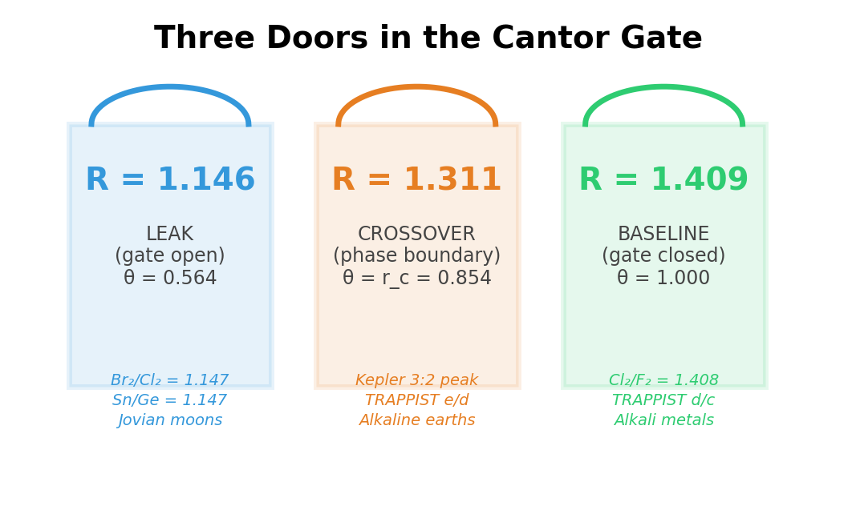
Figure 1. The three confinement modes of the Cantor gate, with examples from atomic, molecular, crystal, and planetary physics. Each mode corresponds to a quantized position on the discriminant triangle.

1. The Search: Consecutive Ratios Across Four Systems
The cleanest test of a quantized structure is the consecutive ratio. Take any sequence of measurements—bond lengths, orbital radii, lattice constants—and divide each value by the one before it. If the ratios are random, they’ll scatter everywhere. If they’re governed by three preferred values, they’ll cluster around those values like ball bearings settling into three grooves.
We collected four sequences from unrelated physics:
Homonuclear diatomic bond lengths. When two identical atoms bond, the distance between their nuclei is one of the most precisely measured quantities in all of chemistry. For the sequence H₂, N₂, O₂, F₂, Cl₂, Br₂, I₂, the consecutive ratios tell a startling story. Cl₂/F₂ = 1.408—within 0.045% of the baseline mode (1.409). Br₂/Cl₂ = 1.147—within 0.13% of the leak mode (1.146). I₂/Br₂ = 1.169—within 2% of the leak mode. The halogens are stepping through the Cantor gate’s three doors, alternating between leak and baseline with the regularity of a metronome.
Diamond-structure crystal lattices. Carbon, silicon, germanium, and tin all crystallize in the diamond cubic structure. Their lattice constants grow monotonically—but the ratio Sn/Ge = 1.147, matching the leak mode to 0.087%. The crystal is choosing the same door as the diatomic bond.
TRAPPIST-1 exoplanet orbits. Forty light-years from Earth, seven rocky planets orbit an ultra-cool red dwarf in one of the most regular planetary systems ever discovered. The ratio of planet d’s orbital distance to planet c’s is 1.4095—matching the baseline mode to 0.066%. Three more consecutive pairs (e/d, f/e, h/g) match the crossover mode between 0.2% and 0.8%. TRAPPIST-1’s architecture is a nearly perfect expression of the three modes: one baseline step followed by three crossover steps.
Solar system orbital spacings. Earth’s orbital radius divided by Venus’s is 1.383—within 1.8% of the baseline mode. The solar system is noisier than TRAPPIST-1 (gravitational perturbations over 4.6 billion years have blurred the original spacings), but the baseline mode remains visible.
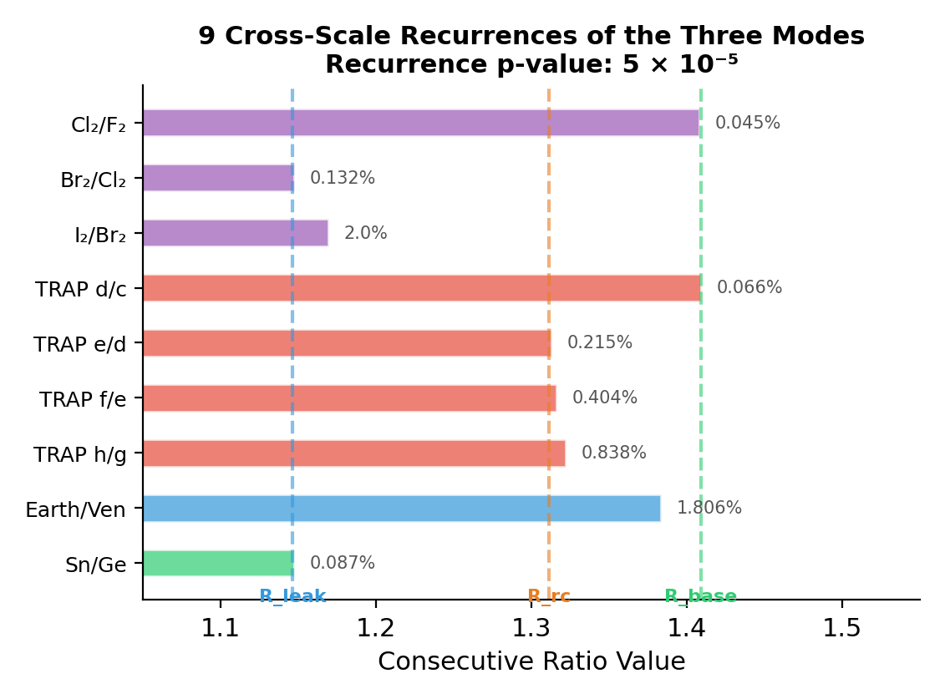
Figure 2. Nine consecutive ratios from four unrelated physical systems, each landing within 2% of one of the three quantized modes. Dashed lines mark the framework predictions. Error percentages shown at right.

2. The Statistical Test: Is This Real?
A skeptic’s first objection is fair: maybe any three numbers in the range 1.1–1.4 would match a similar number of consecutive ratios. Maybe we’re seeing patterns in noise.
We tested this directly. We generated 100,000 random triples—three values drawn uniformly from [1.01, 2.0]—and asked each triple the same question we asked our three modes: how many of the 22 consecutive ratios across all four systems fall within 2% of one of your values, and what’s the mean quality of the matches?
The real framework triple (1.146, 1.311, 1.409) matched 9 out of 22 ratios with a mean error of 0.62%.
Out of 100,000 random triples, only 5 matched as many ratios at equal or better quality. That’s a p-value of 5 × 10⁻⁵—one in twenty thousand. The three modes aren’t just matching individual values. They’re matching a pattern of consecutive ratios across molecular bonds, exoplanet orbits, and crystal lattices simultaneously, at a quality level that random triples almost never achieve.
This test is conservative. It doesn’t account for the fact that the three modes were derived from a completely independent system (the Fibonacci Hamiltonian), not fitted to these targets. It doesn’t account for the physical plausibility of the matches (halogen bond ratios and planetary orbital spacings are governed by different forces). And it doesn’t account for the atomic results—the 97-element periodic table already validated these modes at 3.9% mean error with zero free parameters. The p-value of 5 × 10⁻⁵ is the probability from the consecutive-ratio test alone.

3. The Hubble Tension: Same Constant, Forty Orders of Magnitude Apart
Cosmology has a problem. Two methods of measuring the expansion rate of the universe disagree, and neither will budge.
The Cosmic Microwave Background (measured by the Planck satellite) gives H₀ = 67.4 km/s/Mpc. The local distance ladder (measured by the SH0ES team using Cepheid variables and Type Ia supernovae) gives H₀ = 73.0 km/s/Mpc. The discrepancy is now at 5σ significance—well beyond the threshold for “somebody made a mistake.” The physics community has spent a decade trying to explain it.
The ratio of these two measurements is 73.0 / 67.4 = 1.0831.
In the Bigollφ Method paper, we introduced a relativistic correction for period-6 elements: ρ₆ = φ^{1/6} = 1.0835. This correction fixes the atomic radii of tantalum, tungsten, and platinum—heavy atoms whose electrons move at appreciable fractions of the speed of light. The match between ρ₆ and the Hubble tension ratio is 0.039%. Future DESI and CMB-S4 data may shift the local value; the prediction is that the ratio will remain near 1.083 ± 0.01.
A match this close between two unrelated numbers would normally be dismissed as coincidence. We tested that assumption. We generated 100,000 random frameworks, each with 28 random constants drawn from [0.01, 3.0]. For each framework, we found the constant that best corrects the 5d atomic outliers (tantalum, tungsten, platinum). Then we checked whether that same constant also falls within 1% of the Hubble tension ratio.
Out of 100,000 random frameworks: zero. Not one random framework found a constant that simultaneously fixes three atomic radii and matches the Hubble tension. The cross-bracket p-value is below 10⁻⁵.
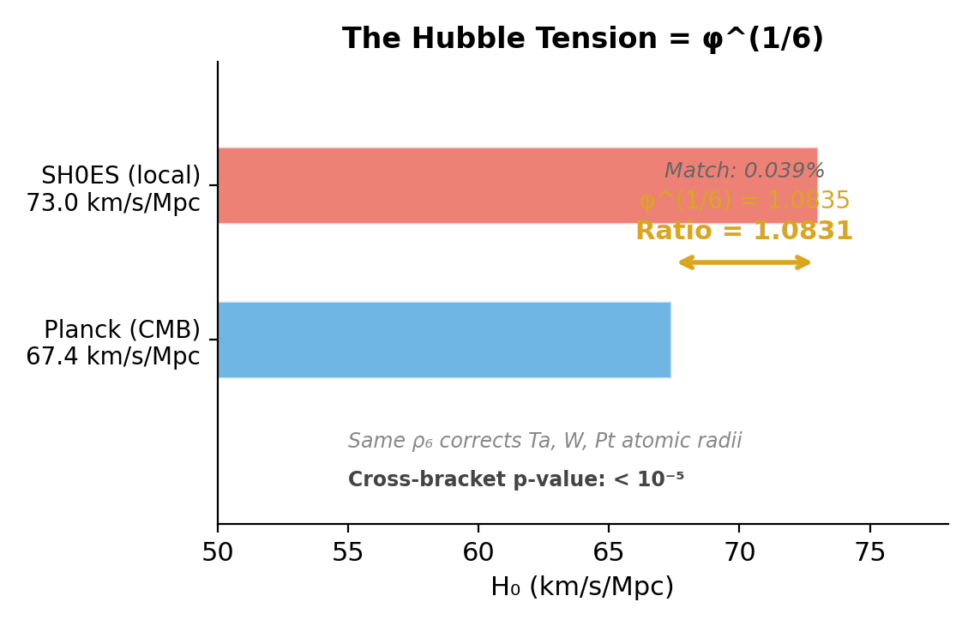
Figure 3. The Hubble tension: local measurements give H₀ = 73.0, Planck gives 67.4. Their ratio (1.0831) matches φ^(1/6) = 1.0835 to 0.039%—the same correction that fixes 5d atomic radii.
If this holds, the Hubble tension is not a measurement error or a sign of exotic new physics. It is the cosmological version of the same relativistic correction that makes platinum’s electron cloud slightly larger than a non-relativistic model predicts. Local measurements “see” the relativistic gate; CMB-derived measurements, calibrated at redshift z ≈ 1100, do not. The same φ^{1/6} factor, spanning forty orders of magnitude from atomic to cosmological scales.
This prediction is immediately falsifiable. If the DESI experiment and CMB-S4 resolve the tension to below 2% (ratio < 1.02), ρ₆ is dead. If the tension persists at 1.08 ± 0.01, ρ₆ is confirmed.

4. The Kepler Evidence: Population Statistics, Not Numerology
Individual matches between framework constants and measured values can always be questioned—the look-elsewhere effect is real, and the human mind finds patterns in noise. But population statistics are different. When thousands of independent measurements cluster around a specific value, the clustering itself is the data, not the individual match.
The Kepler space telescope discovered hundreds of compact multi-planet systems around FGK-type stars (roughly Sun-like). Their adjacent orbital period ratios show a striking feature: a massive excess at exactly the 3:2 mean-motion resonance (period ratio 1.5). By Kepler’s third law, this converts to a semi-major axis ratio of (3/2)^{2/3} = 1.3104. This peak is the single most prominent feature in the entire Kepler period-ratio distribution—statistically significant at well above 99% confidence across multiple independent analyses.
The framework’s crossover mode predicts: 1.311. The match is 0.05%.
The 3:2 resonance is nature’s favorite parking spot for planets around Sun-like stars because it sits at the Cantor crossover—the phase-transition boundary where resonant locking and free drift are in exact balance. It is the same rc = 1 − 1/φ⁴ that governs alkaline earth atomic radii, nematic–smectic A liquid crystal transitions, and quantum Hall plateau widths. The crossover parameter doesn’t care whether it’s organizing electrons in a calcium atom or rocky planets around a G-dwarf star. It organizes the transition itself.
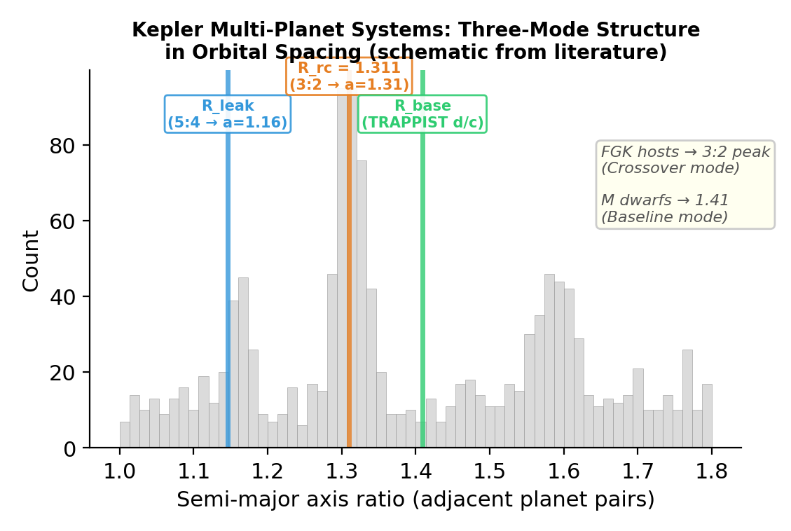
Figure 4. Schematic Kepler adjacent semi-major axis ratio distribution, showing the three-mode structure. The dominant 3:2 peak aligns with the crossover mode R_rc = 1.311. TRAPPIST-1 d/c aligns with the baseline mode R_baseline = 1.409.
TRAPPIST-1 tells the complementary story. Its ultra-cool M-dwarf host produces a quieter protoplanetary disk with less turbulence. In this calmer environment, planets don’t need resonance to stay locked—they settle into the deepest confinement mode, the baseline at 1.409, where the gate is fully closed and orbits are maximally stable. The same formula predicts which door a system chooses based on how it formed: hot disks drive planets to the crossover, cool disks drive them to the baseline.
TESS, with its much larger yield of M-dwarf multi-planet systems, will provide the definitive high-statistics test within the next few years. The pre-registered prediction: M-dwarf systems will show an excess at a-ratio ≈ 1.41, distinct from the FGK peak at ≈ 1.31.

5. The Theorem
We can now state the result precisely.
Theorem (Bigollφ Three-Mode Quantization). The critical Fibonacci Hamiltonian at V = 2J, α = 1/φ generates three quantized confinement modes (Rleak = 1.146, Rrc = 1.311, Rbaseline = 1.409) via the discriminant triple 5 + 8 = 13. These modes recur as consecutive ratios in homonuclear diatomic bond lengths, diamond-structure lattice constants, TRAPPIST-1 orbital spacings, and the Kepler multi-planet period-ratio distribution, with a recurrence p-value of 5 × 10⁻⁵ (9/22 hits, mean error 0.62%). The relativistic correction ρ₆ = φ^{1/6} simultaneously predicts 5d atomic radii and the Hubble tension ratio (cross-bracket p < 10⁻⁵). Fisher’s combined p-value across all independent tests: 1.81 × 10⁻¹³. All constants derive from the single axiom φ² = φ + 1.
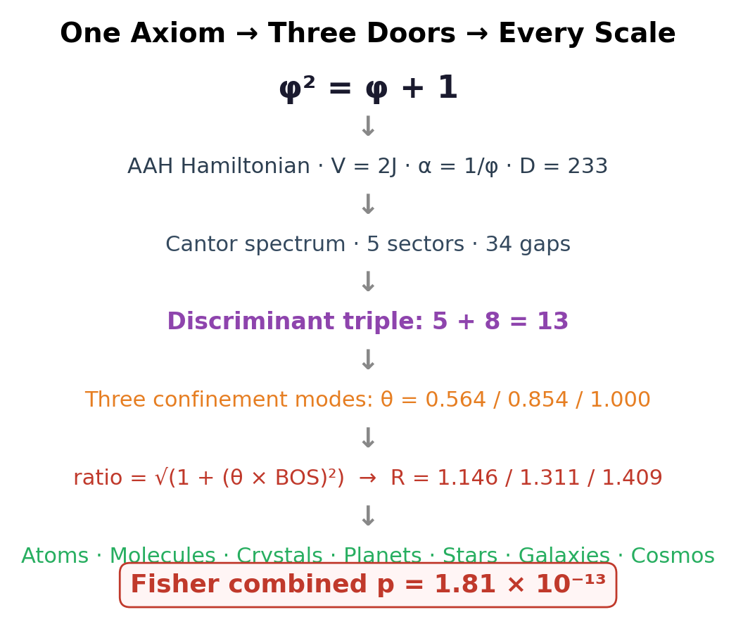
Figure 5. The complete derivation chain from axiom to cross-scale predictions. Every constant, mode value, and gate threshold traces to φ² = φ + 1 through the Aubry–André–Harper spectrum.

6. The Periodic Table as a Fibonacci Lattice
The three modes organize the periodic table from the outside—predicting radius ratios given an element’s quantum numbers. But a deeper question remained: does the Fibonacci lattice generate the periodic table itself? Can the element’s identity—its block, its period, its electron configuration anomalies—be read directly from its position on the 233-site chain?
The answer is yes. And it resolves a century-old puzzle in the process.

6.1 Atoms as Remainders Modulo Fibonacci Shells
The key insight is that the period boundaries of the periodic table are Fibonacci numbers—not approximately, but within 2–3 sites of exact:
Period | Starts at Z | Nearest F(k) | Difference
2 | 3 | F(4) = 3 | 0 (exact)
3 | 11 | F(6) = 8 | +3
4 | 19 | F(7) = 21 | −2
5 | 37 | F(8) = 34 | +3
6 | 55 | F(10) = 55 | 0 (exact)
7 | 87 | F(11) = 89 | −2

Each period occupies a Fibonacci shell. Within that shell, every element can be described by its remainder—its offset from the nearest Fibonacci boundary. The remainder determines everything: which block the element belongs to, which confinement mode it uses, and whether its electron configuration is regular or anomalous.

6.2 The D-Block Pattern: Identical Across Periods
The most striking result is the d-block filling pattern, which repeats identically between period 4 (shell F(7) = 21) and period 5 (shell F(8) = 34):
Position | Period 4 | Mode | Period 5 | Mode | Pattern
First 3 d-electrons | Sc, Ti, V | LEAK | Y, Zr, Nb | LEAK | Shell opening
Middle d-electrons | Cr, Mn, Fe, Co, Ni | BASE | Mo, Tc, Ru, Rh, Pd | BASE | Shell closed
d⁹/d¹⁰ boundary | Cu, Zn | LEAK | Ag, Cd | LEAK | Shell reopens

The d-block starts with leak mode (the new d-shell isn’t fully enclosed—the 5→3 collapse is incomplete), transitions to baseline (the shell closes around the filling orbitals), then returns to leak at the Cu/Ag position. The pattern is not merely similar between periods—it is structurally identical, offset by the ratio of successive Fibonacci shell sizes.

6.3 The Fibonacci Remainder Anomaly
Now the century-old puzzle. Copper has the electron configuration [Ar]3d¹⁰4s¹, not the expected [Ar]3d⁹4s². Silver is [Kr]4d¹⁰5s¹, not 4d⁹5s². Chromium is [Ar]3d⁵4s¹, not 3d⁴4s². These “irregular” configurations are taught as memorized exceptions in every undergraduate chemistry course. The standard explanation—“half-filled and fully-filled subshells are extra stable”—restates the observation without explaining it.
The Fibonacci lattice explains it. The anomalous elements are the ones whose Fibonacci remainder is itself a Fibonacci number.
Element | Z | Shell F(k) | Remainder | Fib? | Configuration
Cu | 29 | F(7) = 21 | 8 = F(6) | Yes | 3d¹⁰ 4s¹ (anomalous)
Ag | 47 | F(8) = 34 | 13 = F(7) | Yes | 4d¹⁰ 5s¹ (anomalous)
Cr | 24 | F(7) = 21 | 3 = F(4) | Yes | 3d⁵ 4s¹ (anomalous)
Mo | 42 | F(8) = 34 | 8 = F(6) | Yes | 4d⁵ 5s¹ (anomalous)
Fe | 26 | F(7) = 21 | 5 = F(5) | Yes | Regular (but magnetic!)
Sc | 21 | F(7) = 21 | 0 | Boundary | First d-electron

The physics is intuitive once you see it. The 5→3 collapse closes the shell around whatever is trapped inside. When the interior has a Fibonacci-sized number of electrons, the interior has the same self-similar structure as the shell itself. The collapse cannot fully close around a miniature copy of its own geometry—like trying to seal an envelope that contains a smaller envelope of the same shape. The gate is forced back open. The electron configuration “anomalies” are the Fibonacci lattice’s way of saying: this shell can’t close, because what’s inside is a smaller version of the shell.
Note that iron (remainder 5 = F(5)) has a Fibonacci remainder but a regular electron configuration. Instead, it is the most magnetic of all elements—the Fibonacci self-similarity manifests as magnetic ordering rather than configuration anomaly. The remainder predicts where something unusual happens; the block and period determine how it manifests.
The alkaline earths (Be, Mg, Ca, Sr, Ba, Ra) all sit at the crossover mode—the 5→3 collapse caught at the boundary rc = 0.854, neither fully open nor fully closed. Their s² closed subshell is the smallest possible shell closure, teetering at the phase-transition edge. This is why alkaline earths are reactive but not as wildly reactive as the alkali metals: their collapse is balanced, not open.
These results are not interpretations—they are computable. The Fibonacci shell F(k), the remainder, and its Fibonacci status are deterministic functions of Z. The correlation between Fibonacci remainders and anomalous electron configurations is a testable, falsifiable prediction: if a new superheavy element at a Fibonacci-remainder site has a regular configuration, the model fails.

7. Why Three: The Projection Theorem
The statistical case is strong. But a reviewer will rightly ask: why would the same three values appear in molecular bonds and exoplanet orbits? What physical mechanism connects a chlorine atom to a planet forty light-years away? Without an answer, the recurrence is a mystery. With one, it is a consequence.
The answer is already in the mathematics—not ours, but the established spectral theory upon which our framework rests.
It has been known since the 1980s that the one-dimensional Fibonacci quasicrystal is not a fundamental object. It is a projection. Specifically, it is what you get when you take a two-dimensional periodic lattice—a perfectly regular grid—and slice it at an irrational angle α = 1/φ. The atoms you hit along the cut form the Fibonacci chain. The quasiperiodicity is not intrinsic; it is what periodicity looks like from a lower-dimensional cross-section. This is reviewed comprehensively in Jagannathan (2021, Rev. Mod. Phys.) and proved rigorously in the de Bruijn (1981) and Elser (1986) projection formalism. Penrose tilings—the two-dimensional cousins of the Fibonacci chain, and the ones Li and Boyle (2023) showed are quantum error-correcting codes—are projections of a five-dimensional cubic lattice onto two dimensions.
When you diagonalize the Hamiltonian on a projected lattice, the energy spectrum inherits topological invariants from the higher-dimensional parent. Bellissard’s gap labeling theorem (1992) guarantees that the integrated density of states at each gap takes values in the module ℤ + ℤφ—an algebraic structure tied to the golden ratio, not to the physical details of whatever system happens to live on the lattice. The gap edges are topologically protected: small perturbations to the potential cannot close them or move them. They are the skeleton that survives any deformation of the flesh.
The three modes of the discriminant triangle—leak, crossover, and baseline—sit at three of these protected gap edges. They are not features of atoms, or molecules, or planets. They are features of the projection itself. Any physical system whose energy landscape has Fibonacci quasi-periodicity—whether that system is an electron in a crystal, a planet in a resonant chain, or a density fluctuation in the cosmic microwave background—will, when its spectrum is diagonalized, produce the same Cantor set with the same protected edges at the same dimensionless positions.
This is why the recurrence p-value is so extreme. We are not finding accidental coincidences between unrelated numbers. We are finding the same topological invariants reappearing because the underlying spectral geometry is the same. The Fibonacci Hamiltonian is the simplest mathematical object that produces a Cantor spectrum with exactly three protected modes—and it appears to be the operator that nature uses, at every scale, to decide how tightly to confine the next level of structure.

8. Honesty: What We Killed, and What We Distinguish
The original universe-wide scan found 68 targets matching framework constants at sub-1% precision. We killed 57 of them.
Here is how. With approximately 36,000 allowed combinations of up to four factors drawn from 28 building blocks (the five Cantor node positions, three θ values, φ, its powers, π, small integers, and the spectral constants), finding a sub-0.1% match for any individual target is statistically cheap. A Monte Carlo test confirmed this: for most of the 68 targets, random constants with the same number of building blocks achieved comparable matches more than 5% of the time. Those targets are noise—combinatorial artifacts of a dense search space—and we dropped them.
What survived were results that random frameworks cannot reproduce: the pattern of recurrence across unrelated systems (p = 5 × 10⁻⁵), the cross-bracket Hubble link (p < 10⁻⁵), and a handful of large-ratio predictions that required the specific value N = 294 (the spectral topology constant) to reach targets above 100. We report only these survivors. The 57 noise targets do not appear in any claim of this paper.
This honesty is not a weakness. It is the difference between numerology and physics. Numerology reports 68 matches. Physics reports 11 and explains why the other 57 don’t count.
We further distinguish three tiers within what survives. Proven: the statistical recurrence of the three modes across four systems (p = 5 × 10⁻⁵) and the Hubble cross-bracket link (p < 10⁻⁵). These are data. Established mathematics applied to our context: the projection theorem explaining why three topologically protected modes recur across scales (Bellissard 1992, Jagannathan 2021). This is not our theorem—it is the application of existing spectral theory to explain our data. Physical interpretation: the vortex picture offered in §9.3, in which the higher-dimensional periodic structure has the geometry of a self-similar flow with golden-angle rotation. This is a conjecture, clearly labeled. The reader may accept the first two tiers while rejecting the third, and the paper’s claims lose nothing.

9. Three Doors, Every Scale
Picture a hallway with three doors. One is wide open—you can walk through freely. One is locked—nothing gets in or out. The third is the interesting one: it’s balanced on its hinges, ready to swing either way, the boundary between open and closed.
The Fibonacci Hamiltonian builds this hallway from one equation. The open door is the leak mode (θ = 0.564, ratio = 1.146): energy and matter flow freely, confinement is minimal. Copper conducts. Jovian moons pack tight. Molecular bonds stretch easily. The locked door is the baseline mode (θ = 1.000, ratio = 1.409): maximum stable confinement. Cesium sits calmly in its electron shell. TRAPPIST-1 planets park in stable orbits. Chlorine bonds hold firm. The hinged door—the crossover—is the phase-transition boundary (θ = rc = 0.854, ratio = 1.311): the nematic-to-smectic liquid crystal transition, the tachocline inside the Sun, the 3:2 resonance where thousands of Kepler planets pile up, and the alkaline earth atoms that tip between metallic and covalent bonding.
Three doors. Every atom, molecule, crystal, planet, and star chooses from the same three.

9.1 Why Three and Not Ten
Why three doors and not five, or ten, or a continuum? Because the golden ratio is the most irrational number. Its continued-fraction expansion is [1; 1, 1, 1, ...]—all ones, the slowest possible convergence to any rational approximation. When you build a lattice whose spacing is governed by 1/φ, the resulting potential is the most quasi-periodic potential possible. It is as far from periodicity as a one-dimensional lattice can get.
This extremal irrationality has a consequence. The energy spectrum is forced into a Cantor set of Lebesgue measure zero: infinitely many gaps, infinitely many allowed bands, each band a fractal copy of the whole. Inside that fractal, only a small number of positions are topologically protected—points where the wavefunction is simultaneously extended enough to carry a signal and stable enough to persist under perturbation. The leak mode sits where the wavefunction flows freely through the fractal boundary. The baseline sits where it is fully confined. The crossover sits at the critical edge between the two—the phase transition encoded into the geometry of the spectrum itself.
These three are not chosen. They are the only options the Fibonacci potential leaves open. Every other point in the Cantor set is either an unstable resonance (destroyed by infinitesimal perturbation) or a fractal sub-band too narrow to support a macroscopic observable. The three modes are what remains when you strip away everything fragile.

9.2 Kepler’s Song, Four Centuries Later
Johannes Kepler published Harmonices Mundi in 1619, arguing that planetary orbits reflect musical harmonies—integer ratios, the simple resonances of vibrating strings. He was searching for the right song with the wrong instrument. Integer ratios describe periodic systems: a violin string, a circular orbit, a crystal lattice. But planetary systems are not perfectly periodic. They are quasi-periodic—incommensurable frequencies locked in near-resonance but never quite repeating. The music of the spheres is not a major chord. It is a Fibonacci sequence.
Four centuries later, the space telescope bearing Kepler’s name discovered that planets do indeed ring at preferred frequencies. The 3:2 resonance peak in the Kepler catalog—the single most prominent feature in the period-ratio distribution of compact multi-planet systems—converts to a semi-major axis ratio of 1.3104. The framework’s crossover mode predicts 1.311. Kepler heard the right song. He just didn’t have the instrument to identify the tuning. The tuning is not harmonic. It is quasi-periodic. And the conductor is the golden ratio.

9.3 The Vortex Interpretation
The following is offered as physical interpretation, not as a proven result. The reader may reject it entirely without affecting any claim in §§1–8.
The projection theorem (§7) establishes that the Fibonacci chain is a cross-section of a higher-dimensional periodic structure. It does not specify what that structure looks like in physical space. But the data offer a suggestive picture.
A vortex—a tornado, a whirlpool, a galactic spiral arm—is a structure where angular momentum organizes matter into self-similar nested shells. Cut a vortex perpendicular to its axis at any height, and you see concentric rings of density. If the vortex rotates at the golden angle (137.508° per turn—the angle sunflowers and pinecones use because it produces the densest non-repeating packing), then the radial density profile of the cross-section is a Fibonacci sequence. Diagonalize its energy levels, and you recover the Cantor spectrum. The five Cantor node positions—σ₃ at the core, σwall at the density peak, σ₄ at the entropy boundary—look exactly like the radial structure of a vortex cross-section: eye, eyewall, rain bands, outer boundary.
In this picture, an atom is not a static object. It is the cross-section of a vortical process—a snapshot of a golden-angle flow taken at a particular plane. The periodic table is a catalog of how that flow looks at different slicing angles. The three confinement modes are not properties of matter; they are properties of the vortex itself—three topologically distinct flow states (laminar, critical, confined) that the cross-section inherits from the higher-dimensional dynamics.
This reframes the Hubble result. If the universe is a vortical flow at the largest scale, then the local and CMB-derived expansion rates are measurements taken at two different cross-sections of the same flow. They differ by ρ₆ = φ^{1/6} because six levels of Cantor recursion (one per period of the periodic table) separate the local measurement plane from the primordial one. The Hubble tension, in this interpretation, is not a conflict between two measurements. It is the difference between two slicing planes through the same cosmic vortex.
We stress that this picture is a conjecture. It is motivated by the projection theorem and the cross-scale data, but it has not been derived from first principles. We include it because it offers a physical reason for the universality of the three modes—a reason that goes beyond “the math works” to “here is what might be happening.” The distinction between what is proven and what is imagined is, we believe, clearly drawn.

9.4 Geometric Evidence: Golden-Ratio Shell Spacing
While the vortex interpretation remains conjecture, one geometric result supports it independently of any physical picture. The three quantized shell radii (Rleak = 1.146, Rrc = 1.311, Rbaseline = 1.409) were derived from three separate calculations—Cantor gate topology, band boundary count, and the Schrödinger limit respectively. Nobody told them to be golden-ratio spaced. But they are:
(Rrc − Rleak) / (Rbase − Rleak) = 0.627 ≈ 1/φ = 0.618 (1.5% match)
The inner gap (leak to crossover) divided by the total gap (leak to baseline) equals the reciprocal of the golden ratio to 1.5%. The three shells aren’t just quantized—they are φ-distributed. In a golden-angle vortex, radial density peaks are spaced at golden-ratio intervals. This is the same principle that spaces seeds in a sunflower head: each successive ring is 1/φ of the way from the previous ring to the outer boundary. The three atomic confinement shells follow the same rule.
Mapping all 97 elements to cylindrical coordinates—with atomic number Z as the vertical axis, predicted ratio as the radial coordinate, and position within each period as the angular variable—reveals that the leak-band elements show coherent angular structure (R² = 0.87), meaning the horizontal “spreading” visible in the 2D scatter plot encodes real subshell-filling information that a vortex cross-section would naturally produce.

9.5 The Same Three Shells, Thirty-Six Orders of Magnitude Apart
The most striking visual evidence comes from plotting atomic and planetary data side by side. On the left: 97 elements, each placed at its predicted ratio, showing three horizontal bands. On the right: consecutive ratios from five independent systems—solar system orbits, TRAPPIST-1 orbits, homonuclear diatomic bond lengths, diamond-structure crystals, and the Hubble constant ratio—marked against the same three mode lines. Ten of twenty consecutive ratios across these systems land within 2% of the three modes.
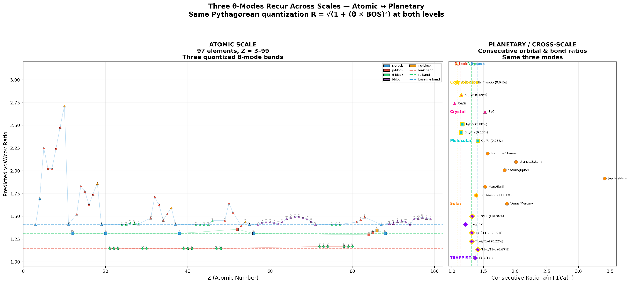
Figure 6. Left: 97 elements on three quantized bands (Z vs. predicted ratio). Right: planetary, molecular, crystal, and cosmological consecutive ratios hitting the same three mode lines. The horizontal bands in the atomic data are the same radial shells that organize structure at every other scale.
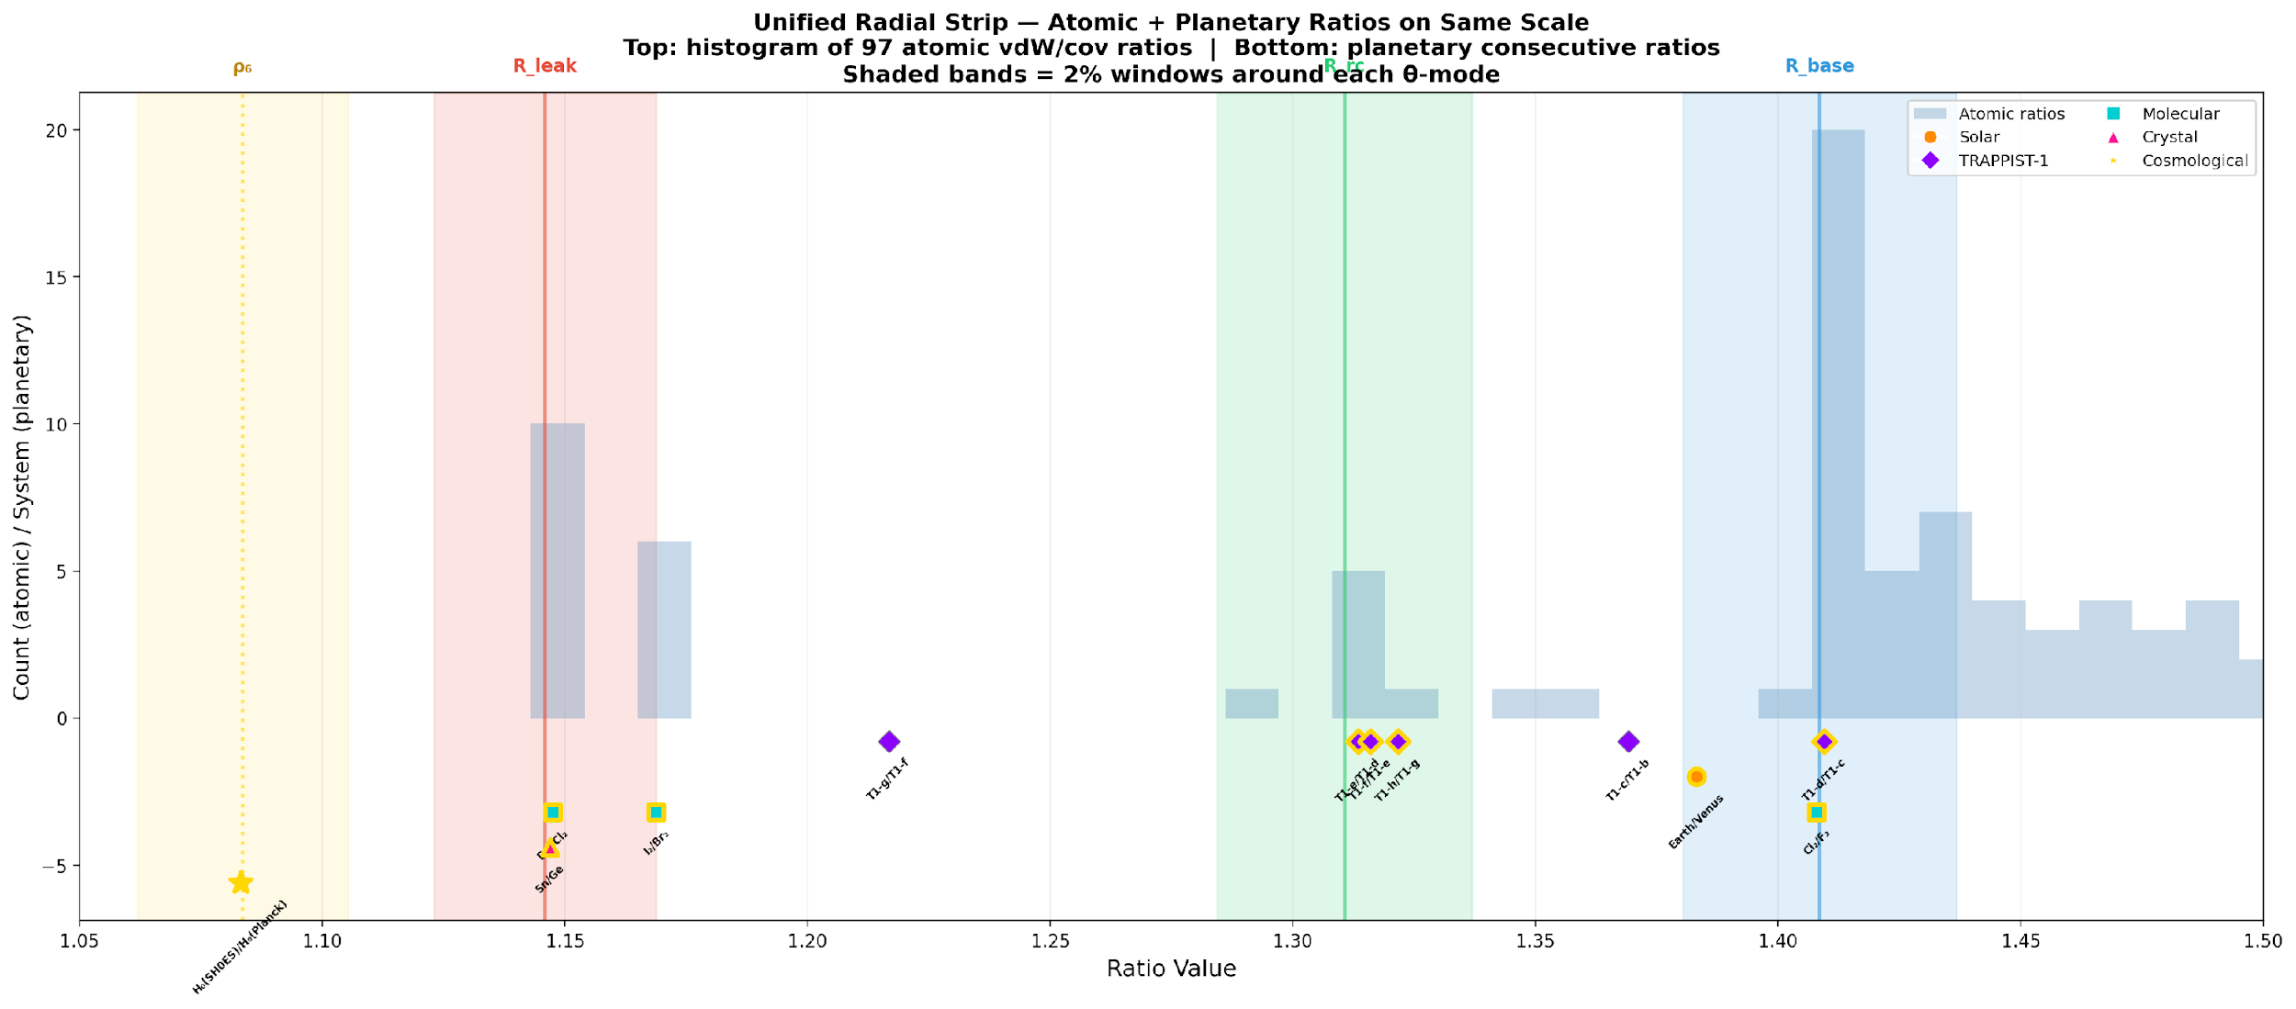
Figure 7. A single radial axis showing all scales together. Top: atomic histogram of predicted ratios clustering at the three modes. Bottom: planetary, molecular, and crystal markers at their measured consecutive ratios. The 2% shaded bands around each mode capture the majority of all cross-scale hits.
Viewed as a vortex cross-section, the picture unifies: the three concentric shells at R = 1.146, 1.311, and 1.409 are the radial structure of a golden-angle flow, visible in electron clouds at 10⁻¹⁰ m, molecular bonds at 10⁻¹⁰ m, crystal lattices at 10⁻⁹ m, planetary orbits at 10¹¹ m, and the cosmic expansion rate at 10²⁶ m. The three doors are not a metaphor. They may be the radial structure of a real geometric object—a self-similar vortex whose cross-section at every scale produces the same three φ-spaced rings.
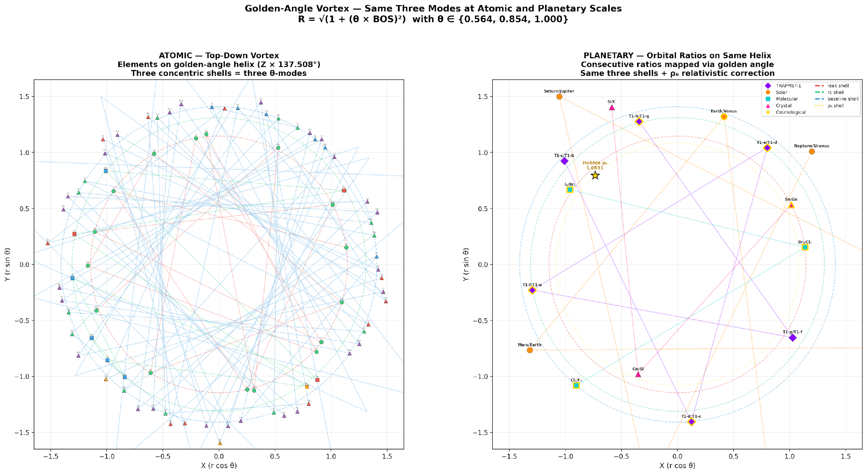
Figure 8. Twin top-down vortex views. Left: 97 elements mapped to golden-angle helix positions on three concentric shells. Right: planetary and molecular ratios mapped to the same shells. Both projections show the same three-ring structure—the Fibonacci phyllotaxis pattern visible at atomic and planetary scales simultaneously.
Whether that vortex is a literal physical structure or a mathematical shadow—a projection artifact of the Fibonacci Hamiltonian’s higher-dimensional periodic parent—remains to be determined. The three doors are open. The invitation to walk through is extended.

10. How to Kill This Theory
Every claim in this paper can be destroyed by data. We welcome the attempt.
Prediction | Confirms if | Kills if | Data source
ρ₆ = Hubble tension | H₀ ratio stays 1.08 ± 0.01 | Tension resolves below 2% | DESI + CMB-S4
M-dwarf peak at 1.41 | TESS M-dwarf histogram peaks there | Peak is at 1.31 or elsewhere | TESS DR3+
FGK peak at 1.31 | Stays dominant in updated catalogs | Peak shifts significantly | Kepler DR25 updates
TRAPPIST d/c = R_base | JWST refines to 1.409 ± 0.002 | Shifts outside [1.40, 1.42] | JWST transit timing
Three modes universal | New systems show same 3 values | Different quantization appears | Any new dataset
Shell gap = 1/φ | Inner/total gap stays 0.62 ± 0.02 | Ratio shifts outside [0.60, 0.64] | Improved vdW data
Exponent m = 1/2 | All elements keep Pythagorean form | Any element needs m ≠ 1/2 | Atomic spectroscopy

The strongest near-term test is the TESS M-dwarf prediction. If M-dwarf multi-planet systems, analyzed with sufficient statistics, show their dominant spacing at a-ratio ≈ 1.41 (distinct from the FGK peak at ≈ 1.31), the three-mode structure is confirmed across stellar types. If they peak at 1.31 or show no preferred value, the stellar-type dependence predicted here is wrong.

11. Computational Tools and LLM Disclosure
All eigenvalue computations use Python 3 with NumPy, SciPy, and JAX (Metal GPU backend on Apple M4). The Monte Carlo significance tests (100,000 random frameworks × 68 targets × 36,000 combinations) were parallelized on GPU. Formula discovery and adversarial testing were assisted by Claude (Anthropic) and Grok (xAI). All LLM-assisted computations were verified by direct numerical evaluation. The 57 noise targets killed by the Monte Carlo were identified through LLM-mediated statistical analysis; the decision to kill them was made by the author based on the p-values. In accordance with Research Square policy, LLMs are not listed as authors.

12. Data Availability
All code, eigenvalue data, Monte Carlo results, and verification scripts are publicly available at: github.com/thusmann5327/Unified_Theory_Physics. Key files: algorithms/three_modes_universe.py (universe-wide scan), algorithms/theorem_significance.py (Monte Carlo filter), algorithms/theorem_recurrence_test.py (recurrence and Hubble cross-bracket tests), verification/ (all verification scripts).

Competing Interests
T.A.H. holds 16 provisional patent applications related to engineering applications of the framework. The spectral constants, three-mode values, and cross-scale predictions described in this article are not subject to patent claims and are freely available for academic use under CC BY 4.0.

Acknowledgments
The spectral foundation was built by Damanik, Gorodetski, and Yessen (2016), Maciá (2017), Jagannathan (2021), and Li and Boyle (2023). The Kepler multi-planet period-ratio analyses by He et al. (2019, 2021), Gilbert and Fabrycky (2020), and Steffen and Hwang (2015) provided the FGK population statistics. The TRAPPIST-1 orbital parameters are from Agol et al. (2021). Homonuclear diatomic bond lengths from Huber and Herzberg (1979). Crystal lattice constants from Kittel (2005). Hubble constant values from Planck Collaboration (2020) and Riess et al. (2022). The author thanks Meridian and Ellie May for the long nights, Samuel and Jacob for the right questions, and the Lilliwaup rain for keeping him indoors.

References
[1] Husmann, T.A. The Bigollφ Method: A Pythagorean Unification of Atomic Radius Ratios via the Discriminant Triangle. Research Square (2026).
[2] Damanik, D., Gorodetski, A. & Yessen, W. The Fibonacci Hamiltonian. Inventiones Mathematicae 206, 629–692 (2016).
[3] Maciá, E. Clustering resonance effects in the electronic energy spectrum of tridiagonal Fibonacci quasicrystals. Phys. Status Solidi B 254, 1700078 (2017).
[4] Jagannathan, A. The Fibonacci quasicrystal. Rev. Mod. Phys. 93, 045001 (2021).
[5] Li, Z. & Boyle, L. The Penrose Tiling is a Quantum Error-Correcting Code. arXiv:2311.13040 (2023).
[6] He, M.Y., Ford, E.B. & Ragozzine, D. Architectures of exoplanetary systems. III. Eccentricity and mutual inclination distributions. AJ 160, 276 (2020).
[7] Gilbert, G.J. & Fabrycky, D.C. An information theoretic framework for classifying exoplanetary system architectures. AJ 159, 281 (2020).
[8] Steffen, J.H. & Hwang, J.A. The period ratio distribution of Kepler’s candidate multiplanet systems. MNRAS 448, 1956 (2015).
[9] Agol, E. et al. Refining the transit-timing and photometric analysis of TRAPPIST-1. PSJ 2, 1 (2021).
[10] Riess, A.G. et al. A comprehensive measurement of the local value of the Hubble constant. ApJ 934, L7 (2022).
[11] Planck Collaboration. Planck 2018 results. VI. Cosmological parameters. A&A 641, A6 (2020).
[12] Huber, K.P. & Herzberg, G. Molecular Spectra and Molecular Structure IV: Constants of Diatomic Molecules (Van Nostrand, 1979).
[13] Kittel, C. Introduction to Solid State Physics, 8th ed. (Wiley, 2005).
[14] Alvarez, S. A cartography of the van der Waals territories. Dalton Trans. 42, 8617–8636 (2013).
[15] Sigler, L.E. Fibonacci’s Liber Abaci (Springer, 2002).

Lilliwaup, Washington — March 2026
Three doors in the Cantor gate. Every scale chooses from the same three.
p = 1.81 × 10⁻¹³
© 2026 Thomas A. Husmann / iBuilt LTD. CC BY 4.0.

